**Name: SHAMJAD MAZOOD NAZER**

**Roll No: 36**

**Batch: B**

**Date: 24-03-2022**

**NETWORKING & SYSTEM ADMINISTRATION LAB**

**Experiment No.: 2**

**Aim**

Familiarization of Linux Commands.

**Procedure**

1. **pwd:** Print name of current/working directory.

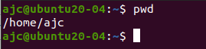

1. **mkdir:** ‘mkdir foldername’ creates makes directory in the current location.

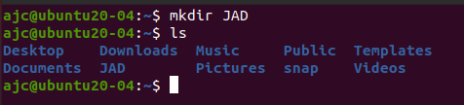

1. **man:** This command helps you with the description of a specified mentioned command.   
   E.g., ‘man ls’.



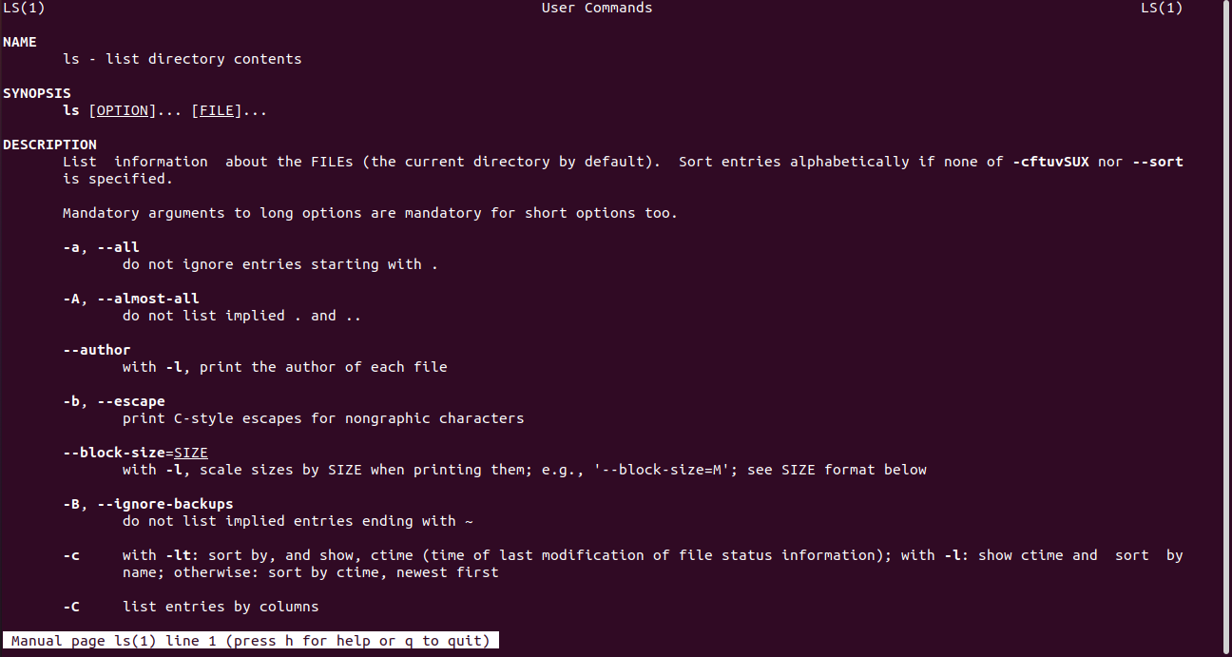

1. **ls:** ‘ls’ command list directory contents.



* 1. **ls -l:** Brief description of a directory (list).

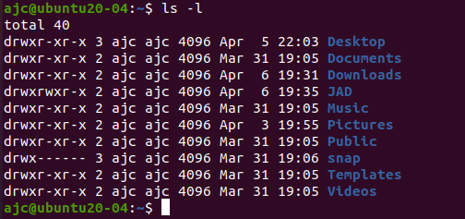

* 1. **ls -r:** Shows the directory in reverse order.

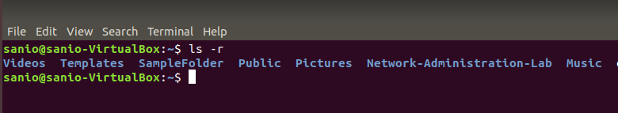

* 1. **ls -a:** Shows all files (hidden).



* 1. **ls -A:** This helps to list down all the hidden files and folders except the “.” and “..” folders.



* 1. **ls -t:** Display directories as last modified order.

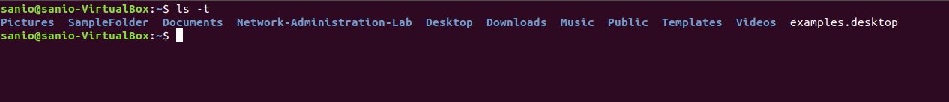

1. **cd:** To change the directory.



* 1. **cd ‘path’:** This variation is used to change current directory to another directory using the mentioned path.



* 1. **cd - :** These helps to move back to the previous stated directory.



* 1. **cd .. :** This simple command helps to go one directory back if exists.



1. **cat:** The ‘cat’ command is used concatenate files and print on the standard output.

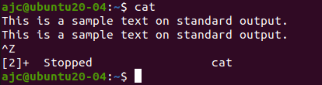

* 1. **cat > ‘filename’:** This type is used to create filename and write data within the file.   
     E.g., cat file.txt.

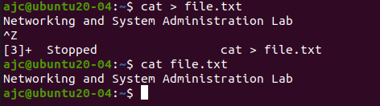

* 1. **cat >> ‘filename’:** This command helps to append text to a file.

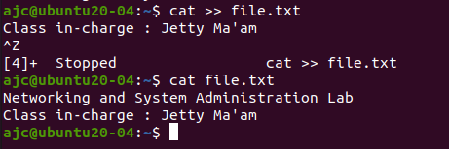

* 1. **cat ‘filename’:** The commands is used to print the data within the mentioned file which is in the current directory. If such file doesn’t exist, then the command creates an empty file with that name.

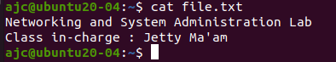

* 1. **cat ‘file1 name’ > ‘file2 name’:** This command helps you to copy the content in a file to another file.

